Annex 4
Outline of Examplary Cases
1. Case Title
2. Project overview
Use a max. of 500 words to explain the following: the pollution problems to be addressed, treatment capacity, system construction and testing/tuning, normal operation time, etc.
3. Overall Concept of the Processes
(1) Technological processes
Use a max. of 500 words to summarize the following items related to the project: process and design theories, technological processes, major process parameters, and special functions. Process diagrams or pictures of facilities may be attached.
(2) Key technological or design features
Use a max. of 500 words to summarize the following items adopted by the project: key process technologies, features of the process layout, special design or apparatus, any use of new materials or systems, etc.
4. Technical indicators
Use a max. of 500 words to describe the following items related to the project: main pollutants, removal efficiency, applicable emission standards and information about standard compliance, annual reduction volume for main pollutants, main by-products, operation and maintenance parameters of key equipment/facilities (e.g. fillings and catalysts), emission indicators of secondary pollutions, water and energy conservation volumes, etc.
5. Investment
Use a max. of 200 words to provide investment profile of the project, including overall investment structure, total investment, investment per unit treatment capacity, etc.
6. Operational costs
Use 200 words to describe annual raw material and energy consumption, as well as raw material and energy consumption per unit of treatment capacity. Calculate annual operational costs as well as operational costs per unit of treatment capacity. Provide data to demonstrate economic benefits of the project if it generates by-products or prominent water or energy conservation effects.
7. User comments
Use a max. of 200 words to provide comments and feedback from end-users of the technology about its features, effects, existing problems, suggestions for its promotion, etc.
8. Contact Information
Provide name of the relevant technical department and its contact person with a telephone number, postal address and an e-mail address in case we need to inquire further details regarding the technicality of the submission.
(Note: please refer to the following Sample of Examplary Case for a drafting template and provide no more than two cases.)

Sample of Examplary Case
1. Case name
Improved UCT process ×××× project (×××× sewage treatment plant).
2. Project overview
The ×××× sewage treatment plant has a daily treatment capacity of ×××m³/d. The sewage is from urban domestic and production sewage and industrial waste water from ××××× industrial park. The construction started in ××/×× (MM/YY) and was put into operation after system testing and tuning in ××/×× (MM/YY). The project won ×××××××× award on ×× /××/×× (MM/DD/YY).
3. Process introduction
(1) Technological process
The project is based on the improved technology for UCT process for realizing the effects of denitrification and dephosphorization. The technological process is as follows: ××××× — ××××× — improved UCT subsection influent biological reaction tank — secondary settling tank — ××××× — ××××× — effluent outflow.
The project adopts the staged influent biological denitrification process, and consists of 3 subsections, each with anoxic/aerobic area connected in series. The raw water flows into each anoxic area and the sludge returns to the head end of the system. The anoxic area of the first subsection uses the carbon source entering the sewage Q1 to perform denitrification on NOx-N of the sludge. Then the mixed liquid flows into the aerobic area to perform the nitrification process. The post-reaction mixed sewage flows into the anoxic area of the second subsection and utilizes the carbon source entering the sewage Q2 to perform denitrification. The mixed liquid then flows into the aerobic area to perform the nitrification process. The steps in the following subsections are performed as above cycles.
(2) Key technological or design features
- The process adopts ×××××××××× influent method and process control to perform denitrification and dephosphorization with the carbon source in the raw water, so as to increase the removal rates for total nitrogen and phosphorous.
- Having established ×××××, ××××× and ××××× control systems to enhance the level of automatic control.
- New technologies such as subsection influent ×××××, ××××× and ××××× are applied for stabilizing outflow quality.
- Advanced denitrification may be realized if an extra carbon source is added.
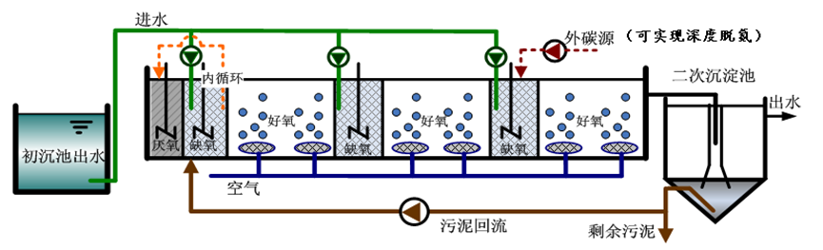
Fig. X-X Improved UCT Technical Process (or photos of facilities)

4. Technical indicators
According to the acceptance report released by ×××, the effluent of the project has met Class 1 A standard of GB18918-2002 Discharge Standard of Pollutants for Municipal Wastewater Treatment Plant. Assuming average influent is TN=××mg/L and TP≦××mg/L, the sewage treatment plant reduces total nitrogen emission by ×× tons and total phosphorus by ×× tons a year. By adding extra proper carbon source and coagulant, advanced denitrification and dephosphorization can be realized (TN≦×mg/L, NH4⁺-N≦×mg/L, TP≦×mg/L0). The technology has been proven prominent in energy saving, with power consumption per ton reduced by ×% and yearly electricity consumption reduced by ×× Kwh.
5. Investment
The total investment for the project is about ×××× yuan, of which, equipment investment is ×××× yuan, infrastructure investment ×××× yuan, other investment ×××× yuan, and investment for per ton water operation is ×××× yuan. The life of main equipment is ×× years and the payback period is ×× years.
6. Operational costs
According to the actual operation from ××/×× (MM/YY) to ××/×× (MM/YY), the annual sewage treatment capacity is ×× tons, annual operation cost ×××× yuan, and per ton water operation cost ×××× yuan. If proper external carbon source and coagulant are added to work with this process to realize advanced treatment, with added carbon source of ×× tons and added coagulant of ×× tons, the annual operation cost will increase by ×××× yuan and operational cost for per ton water operation will increase by ×××× yuan.
7. User comments
The project has brought prominent economic benefits to our company. It is a demonstration project worthy of promotion and application. The project, since its start of operation, has met the design requirements for effluent specifications/standards, with excellent technical indicators. It is of great significance to boost ××××××. The ×××× of the technology is expected to be renovated, so as to strengthen ×××× and further improve ××××.
8. Contact details
Name of entity to respond further inquiries regarding this implementation: ××××××
Contact person: ××××××
Tel.: ××××××
Add.: ××××××
Zip code: ××××××
E-mail: ××××××

